(Approx. 2,211 words)

Tweak Your PC to Keep It Running Fast, Feeling Good and Looking Young!
By Lou Torraca, President MOAA Computer User Group, HI
www.the-tug.org
Af06hi(at)gmail.com

Obtained from APCUG with the author's permission for publication by APCUG member groups.

Last week, I was explaining to a friend that I am a quick launch toolbar afficionado {:-)

What the heck is that he asked. I said I was just referring to the fact I use it instead of the desktop to keep all my shortcuts, actually, lots of shortcuts, at least on my main PC. As we continued to talk about this I found myself explaining a lot of stuff I have done with my PCs and notebook in the past 6 or 8 years! An obvious question came up: “where do you come up with these things?” At that point I explained I call these “things…tweaks” and they come from dozens and dozens of places including many newsletters, also some regular blogs, newspapers, radio shows, other PC users I talk with and of course, the real biggie, MICROSOFT! Yup, their knowledge base contains millions of tips, solutions and you guessed it…TWEAKS! Our conversation ended with a suggestion that I put some “tweaks” in my column, so what follows are some that I like. But first, a reminder, whenever you decide to play, experiment, alter, or as I say, “tweak” an otherwise functioning computer, either do a backup first, or at least, set a restore point you can return to if what you do doesn’t work out for you. If you don’t know how to do that, click on start and then help and support and then choose index and type in system restore.

At the end of this list, I have a couple speed tweaks which I advise should only be used by advanced users, and you will also see I advise again to backup or set a restore point. With that in mind, here is my list.
The area that sits between the start button and the tray (with the clock), on the bottom of your screen, is called the Taskbar.
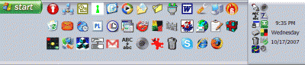
I think one of the best additions you can make to your Taskbar is the Quick Launch Toolbar. Quick Launch gives you fast access to Internet Explorer and Outlook Express, and it includes a Show Desktop icon. It's really easy to open your Quick Launch Toolbar.

Right-click the Taskbar, click on Toolbars, and choose Quick Launch. The Quick Launch Toolbar now appears on your Taskbar right next to your Start button. You'll find the Quick Launch Toolbar very useful and to move all the icons you have on your desktop, just drag and drop them on the QL taskbar. You can play around with it and also expand it if need be. After you drag an icon there, you can delete it off your desktop so you have a neat looking space where I put different pictures every week or so. To be really neat, I hide the whole thing so it automatically disappears until I Point at it with my mouse. Right click on start, properties, taskbar and check auto hide.

If you can copy or move things to a folder, keeping information on your computer more organized is easier. Here is how to add copy or move to a folder to Windows Explorer. Open Windows Explorer (not Internet Explorer) by clicking on Start and then on My Documents. Next, click on an empty area of the standard button bar, the one that starts with the Back button. Last, click on customize. In the available toolbar buttons: list, click on copy to and then click on add to add it to the current toolbar buttons list. Click on Close to complete the customization work. Now the next time you click on a file or folder, the Move to and Copy to folder buttons will appear

If you ever have the need to copy both files and folders to a CD, as in backing up your important information, here's an easy way to do it. Click on Start, and then click on My Computer. Now right-click on your hard drive (usually drive c:) and click on Explore. Now you have a complete list of the files and folders on that drive. Click on any file or folder, and then, while holding down the Ctrl key, click on any other file or folder you wish to copy to a CD/DVD. When you have finished, click on edit, copy to folder. From the list provided click on the CD/DVD R/W (Read/Write) drive you want to send your selection to, and then click Copy at the bottom of that small window. This will result in a folder with those items waiting to be copied. Put in a CD/DVD and click on write these files to CD to the left.

Windows XP has several utilities programs that manage various aspects of XP. You can run any of these utilities by using them as "run" commands. Click on Start, and then click on Run. In the Open: box, type one of these shortcuts and press the Enter key or click OK. control Opens Control Panel clipbrd Opens Clipboard Viewer notepad Opens simple text editor wordpad Opens Word-like text editor compmgmt.msc Computer management devmgmt.msc Device manager diskmgmt.msc Disk management dfg.msc Disk defrag eventvwr.msc Event viewer fsmgmt.msc Shared folders gpedit.msc Group policies lusrmgr.msc Local users and group perfmon.msc Performance monitor rsop.msc Resultant set of policies secpol.msc Local security settings services.msc Services. (Run shows up when you have classic menu selected.)

MY COMPUTER EX GRAPHIC
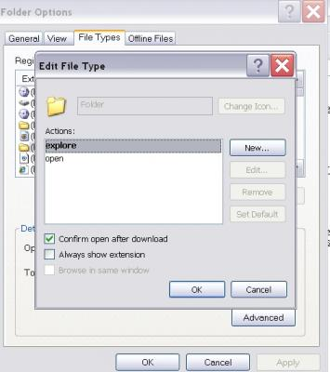
I use My Computer, which shows me all of the drives on my computer, like the floppy drive (A:), the Hard Drive (C:), and others that include DVD and CD drives and removable drives, all the time. Having My Computer show a menu of it’s items as your mouse pointer touches the My Computer link on the start menu is a quick way to get to what you want. To set this up, right-click on the start button, and then click on properties. Click on the customize button and then open the advanced tab. In the start menu items window, scroll down to my computer, and click next to display as a menu. Now click on OK, and again on OK. (This one is the opposite of the one above in that you need to select start menu instead of classic.)

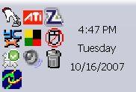

That little area to the right at the bottom of your desktop can get pretty crowded. One way to get more space is to do away with the clock. You can eliminate the clock by right clicking on any blank section of the Task bar, and then clicking on Properties. On the Taskbar tab, click on the checkmark next to "Show the clock" and finally click OK. You can also check the hide inactive icons box to gain a bit more space.

When you click on Start and open My Computer, you have to right-click on a drive and then click Explore to get the "Explore" view of that drive. If you simply double-click on that drive, you get the drive's contents. The Explore view is better because you can work with folders in the left pane and folder contents in the right pane.

To have My Computer open the contents of a drive in the Explore view, from within My Computer click on Tools and then on Folder Options. Open the File Types tab and then click on (NONE) Folder, to highlight it. Now click on the Advanced button, make sure Explore is highlighted, and then click the Set Default button. Click OK, and then click Close.

Now when you open a drive in My Computer it will display in the Explore mode.

Your my documents folder in windows XP holds, by default, your documents, the My Pictures folder and the My Music folder. For most of us, the My Documents folder holds everything you use most.

To make the contents of that folder invisible to nosy folks, do this: Click on Start and right-click on My Documents. Now click on Properties, and then open the General tab. Click in the box next to Hidden in the attributes section and click ok. Now click on Apply, Select "Apply changes to this folder, subfolders and files," and click ok.

This is not encryption, it just makes it harder for a casual user to open your private folders. When you want to view all files again, just reverse the process.

Speeding up your PC is always something most of us think about and the following tweaks are intended to do just that for your XP Pro operating system, but beware, these are intended for advanced users and involve using the registry…not recommended for the faint at heart! Before even considering them, do a registry backup- Here’s how:

Modification of Windows Registry files, which contain settings and other information Windows needs to operate with is risky if you don’t take care. Make a mistake here can cause your PC to stop working. So it makes perfect sense to make a back-up copy of your registry files before you attempt any modifications. Create a batch file to back up your Registry, and then automate the process with an icon on your Desktop.

Click on Start, Run, and then type NOTEPAD. Click OK or press the Enter key. Now you have Notepad open to a blank page. Type "Regedit /E C:\AAAA" (without the quotes) and press the Enter key. Now click on File on the menu bar at the top of the Notepad window, and then click on Save As. In the Save As window, click in the box next to File Name: and type c:\windows\system32\REGBACKUP.BAT. Now click on the down arrow to the right of the Save as type: box and select All Files. Click on the Save button, and close Notepad. To create a shortcut to the registry backup, right-click on the Desktop, click on New and then on Shortcut. At the cursor type c:\WINDOWS\SYSTEM32\REGBACKUP.BAT and click on Next. Now type: Registry Backup and click on Finish.

If you want to change the icon for your new shortcut, right- click on it and click Preferences. Click on the Change Icon button, click Ok when the Change Icon window opens, and then double-click on the icon you want to use. Click OK
Another way to be sure you are safe is to backup your complete computer using either True Image (my favorite) or Ghost…both of which completely copy an image of your entire computer. Also, do a system restore point (see the help menu for how to) this may be the quickest way to go back to where you were if you have problems, but if not, the True Image or Ghost backup will do the trick.

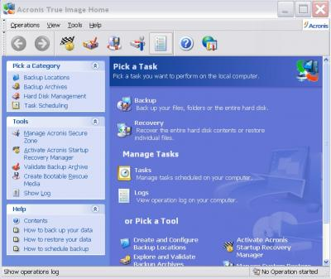
Here's a way to make XP even faster, by making sure that Operating System functions stay in memory (RAM), because memory is much faster than your hard disk. Try this: Click on Start, on Run, and then type REGEDIT and click OK or press the Enter. The word REGEDIT is not case-sensitive. Now double-click on HKEY_LOCAL_MACHINE. Drill down by opening System\CurrentControlSet\Control\Session Manager\Memory Management. Right-click on the DisablePagingExecutive entry located in the right pane (side) of your screen and select Modify. In the Edit DWORD Value dialog box, type the number "1" (without the quotes) in the Value data field. Click OK and then close the Registry Editor. Finally, make sure you don't have any open programs, and restart your computer so that the change you made can take effect.

Lastly, it seems that our Windows XP computers just get bogged down with stuff we don't want or use. One way to get more performance out of your computer is to disable the "last access/update" feature. The NTFS file system in Windows XP maintains last access/update details for each file and directory on your computer's hard drive. This information is useful sometimes but for most of us, this may not be of much use most of the time. This process takes a lot of resources from your computer, so it may make sense to disable it. Once you have done that, you'll still have access to last modified information for files and folders. Here's what you need to do. Click on Start, Run, and at the prompt type REGEDIT and press the Enter key. Now click to open HKEY_LOCAL_MACHINE, and then drill down by clicking on SYSTEM and then on CurrentControlSet, Control and finally on FileSystem. On the right side of the Regedit screen, look for the data key "NtfsDisableLastAccessUpdate."

Double-click on that key and then just set its value to 1. Click OK to save the change and then close the Registry Windows. The next time you boot-up, this change will take place and give you a bit more performance from your Windows XP computer. That’s it so…


Not really, but after all that it is probably time to relax and forget the PC for awhile, so be careful out there while you enjoy all the fun things to do with your new toys and on the ‘net.

Aloha, Lou

This article has been provided to APCUG by the author solely for publication by APCUG member groups. All other uses require the permission of the author (see e-mail address above).

